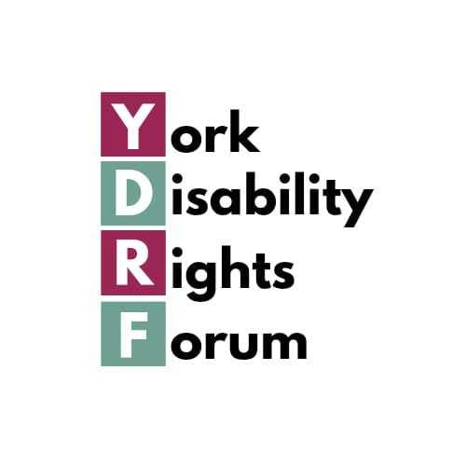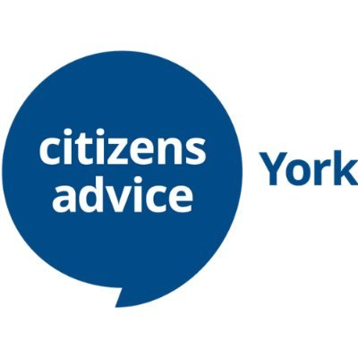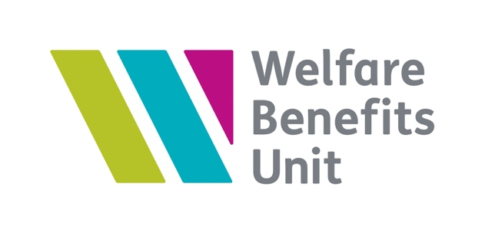
Pathways to Work
Consultation response by:
Citizens Advice York,
Healthwatch York,
Older Citizens Advocacy York,
Welfare Benefits Unit
York Carers Centre,
York Disability Rights Forum,
York Food Bank,
York Human Rights Cities Network,
Professor Charlotte O’Brien University of York, York Law School.
Professor Kate Pickett, Professor of Epidemiology, University of York Dept of Health Sciences,







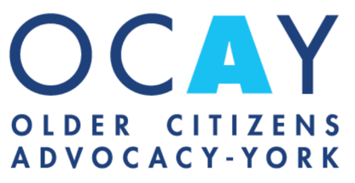

Our consultation response is a collaborative work submitted by: Citizens Advice York, Healthwatch York, Older Citizens Advocacy Service, the Welfare Benefits Unit, York Carers Centre, York Disability Rights Forum, York Food Bank, York Human Rights Cities Network, Professor Kate Pickett Professor of Epidemiology in University of York Dept of Health Sciences, and Professor Charlotte O’Brien University of York, York Law School.
All of our organisations believe that these changes will achieve the opposite of what is intended. Cutting benefits, far from getting people back into work, will reduce the financial support that could help them to remain in work or re-enter the workplace, and will push those who might be able to work further from work.
The changes will force many into poverty, many others from poverty into deep poverty; damage the physical and mental health and wellbeing of many; and increase health inequalities, and homelessness. The full impact will happen slowly because of the transitional protection in place - rather than a sudden dramatic change, there will be an insidious creeping increase in poverty and destitution.
A lot of the language used by some in the debate is also unhelpful, suggesting that someone’s value to society is founded on their ability to work. There needs to be a recognition of the value of all people to society regardless of whether they are able to work.
As recently as last year, in 2024, the UN found that the UK had failed to address ‘grave and systematic’ violations of the UN Convention on the Rights of Persons with Disabilities, in particular through failing to ensure an adequate standard of living and social protection, as a result of benefit cuts already in place. The UK has been invited to report to the UN how it intends to reverse those violations, but is instead planning to deepen and extend the damage with these proposals.
Entitlement to PIP Daily Living should remain as it is currently. Chronically sick and disabled people face many inescapable extra costs if they are to function within society. If they are in work they face further additional costs. Many who can’t work, but will not get PIP or any addition to the basic UC, will be placed in long term deep poverty. The impact a health condition or impairment has on your ability to work and on your chances of securing employment varies enormously. PIP is not a test of whether someone can work. Many people who we spoke to expressed strong and compelling reasons why they can’t work, but wouldn't under the proposed new rules receive PIP. Those in the future who are in their situation would also not receive any addition to their basic UC, and will be placed in long-term, deep poverty.
UK’s low levels of life expectancy and healthy life expectancy will inevitably lead to greater numbers of people in their late fifties and sixties who are unable to work and living in deep poverty. The UK’s higher rate of deaths following a heart attack or stroke, poorer cancer survival, and greater rates of avoidable deaths all contribute to the country’s low ranking on life expectancy. We also have one of the largest health inequality gaps between rich and poor. It is of great concern that a majority of those with these Cardiovascular and Respiratory Diseases who are currently entitled to PIP didn’t receive 4 points in the assessment.
The basic rate of UC was never meant for those out of work long term. Many disabled people are already really struggling financially - these changes will push them into deep poverty.

Living in deep poverty has profound and enduring effects on health outcomes that persist across the lifespan and generations, as evidenced by extensive UK-based research over many decades. International comparative research shows, again consistently, that the UK performs poorly compared to other high income countries, with higher rates of poverty (especially child poverty) and worse health outcomes. The longer that individuals spend in poverty, the worse the outcomes. A vast and robust body of evidence underpins a picture of extreme poverty becoming "embodied" through chronic stress responses, environmental exposures, and cumulative disadvantage, creating health inequalities that compound across generations.

The Disabled Person’s Work Allowance (DPWA) covers the additional costs a disabled person faces as a result of working that are not covered by Access to Work There are 1.7 million people in the LCW and LCWRA groups who are currently entitled to the DPWA if they move into work. If future claimants will need to qualify for PIP to access the DPWA, then, according to DWP’s own figures, only 0.5 million of the most disabled people will qualify. The DPWA works by allowing them to keep more of their earnings not by increasing their award. A Bill that purports to be about supporting people to move into work should not be removing this support for disabled people in work, for future claimants.
The removal of indefinite entitlement to a contributory sickness benefit abolishes a longstanding principle of social insurance. There has been an indefinite entitlement to contributions-based income replacement benefit for people who are too ill or disabled to work ever since the National Insurance Act 1911 - since before the WWI welfare state; and permanent incapacity is a recognised ground for a social security risk in many European welfare regimes. Scrapping this would undermine a core principle underpinning both the ECHR and the UN Convention on the Rights of People with Disabilities - the right of disabled people to live in dignity - and it would violate the ‘legitimate expectations’ of taxpayers.
Delaying access to the health element of UC until the age of 22 would result in intersectional discrimination, on grounds of both age and disability, potentially contrary to Article 14 in concert with A1 P1, and Article 8, ECHR. Such discrimination would be disproportionate, given the small savings at issue, but acute impacts on the affected cohort.
There will be other impacts that don't seem to have been considered such as the impact on disabled students and more disabled people and their carers being subject to the benefit cap. No changes leading to a reduction in the benefits for disabled people should go ahead until there has been a full assessment of the implications of the change.

Our Recommendations
- There should be no reduction in the amount that chronically sick and disabled people receive in benefits until:
- The OBR reports its implications on employment;
- There is an assessment of the ‘hidden’ or unacknowledged cost consequences of increased poverty on the health and social care system;
- The UK government has produced a series of proposals to reverse existing violations of the UN CRPD;
- The EHRC, and the Northern Ireland Human Rights Institution, as the UK’s National Human Rights Institutions, have reviewed any such changes and mitigations and can confirm that they will not worsen existing violations of the UN CRPD.

- DWP should check with the claimant’s nominated health professional first before any reassessment of eligibility to PIP

- In order to genuinely promote employment, and prevent poverty, provision must be made for:
- qualifying for the Disabled Persons Work Allowance (DPWA) at a much lower level of points than the PIP assessment;
- qualifying for the DPWA through the mobility element as well as the daily living element;
- maintaining access to the health element in Universal Credit through the WCA, and keeping it at the same level, until there has been a full assessment of the implications of the change.

- Legislative changes should be made to ensure that:
- PIP receipt is not a condition of eligibility for Universal Credit as a disabled student;
- students on UC who subsequently lose their PIP receive because of this change transitional protection;
- those who become subject to the Benefit Cap, and/or lose Carer’s Allowance receive additional transitional protection.

- Any contributions-based income replacement benefit for people who are too ill or disabled to work must have indefinite entitlement.

- DWP should:
- have a statutory safeguarding duty as they have frequent contact with some of the most vulnerable people in our society;
- work with other local services to ensure that vulnerable people are not left without the benefits they are entitled to;
- Provide mandatory training in disability awareness, listening and communication skills for work coaches.

- Support conversations should:
- be voluntary with no threat of sanctions;
- take account of evidence for the claimant’s own doctor before requiring anyone who claims they are chronically sick or disabled to look for work;
- be subject to exemptions that are set at a lower threshold than the severe conditions criteria.

- The government should not adopt discriminatory provisions:
- No-one should be denied the health element of UC because they are under 22 years of age;
- Children and young adults in education should not be treated as adults; there should be no transition from DLA to PIP until claimants reach 18 or until they leave fulltime non-advanced education - whichever is the later.

- Access to Work should:
- continue to fund standard reasonable adjustments, at least where employers can show they would have difficulty meeting the costs;
- receive sufficient resources to reduce waiting times;
- Provide an AtW assessment for disabled people engaged with the benefits system who want to try out work, to ensure that the support and adjustments would be in place in advance of starting work.

- The government Equality and Human Rights Committee and the Northern Ireland Human Rights Committee should:
- act as impartial intermediaries to assess adjustments, and enforce adjustment decisions, avoiding court, and making workplaces more disability-ready;
- conduct or commission two rigorous surveys – to assess the state of the workplace, and the state of the job market, to quantify the disability employment penalties faced in both.

